[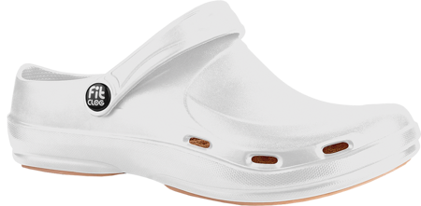](https://clean24.pl/pol_pl_Klapki-buty-medyczne-sanitarne-Fitclog-Basic-001-biale-55806_1.png)